Michael Lanier

**Abstract**

Most high school chemistry classes contain curriculum about boiling point elevation[1], a concept by which a solution boils at a higher temperature than its pure solvent. Later it is discovered that boiling requires nucleation sites, places where oxygen can cluster to form a bubbles[2]. Without this a liquid boils all at once at a much higher temperature. So which is it? Does the presence of a crystal in solution increase of decrease the speed at which a liquid boils? Does it depend on the substance or will any type of granule serve as a nucleation site? These are questions this study hopes to answer.

**Objectives**

Nucleation is defined as the process that determines how long an observer has to wait before a new phase or self-organized structure appears. Our objective is to see how long it takes for heated water to nucleate into bubbles of steam in a solution of water.

**Design**

A CCD design was chosen with two factors, salt and sugar. Axial points were chosen based on orthogonality criteria. 8 center points were run. This design is orthogonal and for first order is rotatable. The proof of the orthogonality is show in appendix 1. The salt treatments had a high level of 2 oz and a low level of 1 oz. At the center points 1.5 was the treatment and at the axial points 2.5 was the treatment. In the analysis these are coded so that high is 1 low is -1, center point run is 0 and axial points are plus or minus 2.

**Procedure**

Runs where randomized. Each run used a flame at constant temperature to heat the solution. Every solution used 8 fluid oz of water. Salt and sugar treatments were added blindly to eliminate bias. Time was recorded until the occurrence of the first bubble on the surface of the liquid. Once a treatment was completed it was poured out and rinsed. One unusual problem was the solution was stick to the bottom of the sink where the pan sat. At one point the sugar stuck to the bottom of the pan and ignited when the pan was planned back on the flame surrounding it in fire. We had to scrape that treatment because it was unsafe to remove it when bubbles occurred because the sugar needed to burn all the way off.

**Sources of error**

Sources of error include non-constant temperature in the water that composed the solution. Measurement errors in the time and imprecise measurement tools in the treatment levels.

**Analysis**

Several models where analyzed. These included a first order model, a second order model, and a model with interaction. In this analysis the salt treatment is X1 and the sugar treatment is X2 The second order and interaction models where deemed inappropriate because their effects where not statistically significant from zero as shown here:  
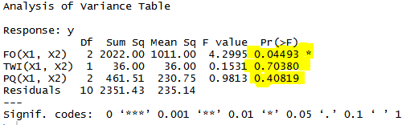.

Additionally the Bayesian information criteria suggests that the first order model is best.

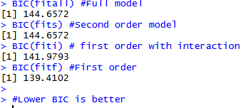

The model in question then is as follows.  
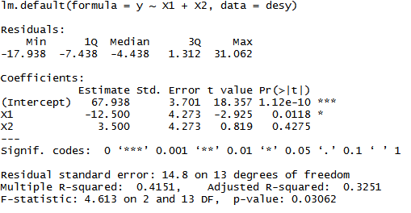

The model here is significant. X1 is also highly significant. X2 is not, however it will be left in the model as a controlling variable. There is sufficient theoretical reason that sugar would be a factor- so for the interest of the science it will be included.

**Model Diagnostics**

* **Lack of fit**

A lack of fit test shows we do not have a lack of fit issue.

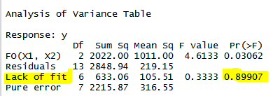

* **Outliers and Influential points**

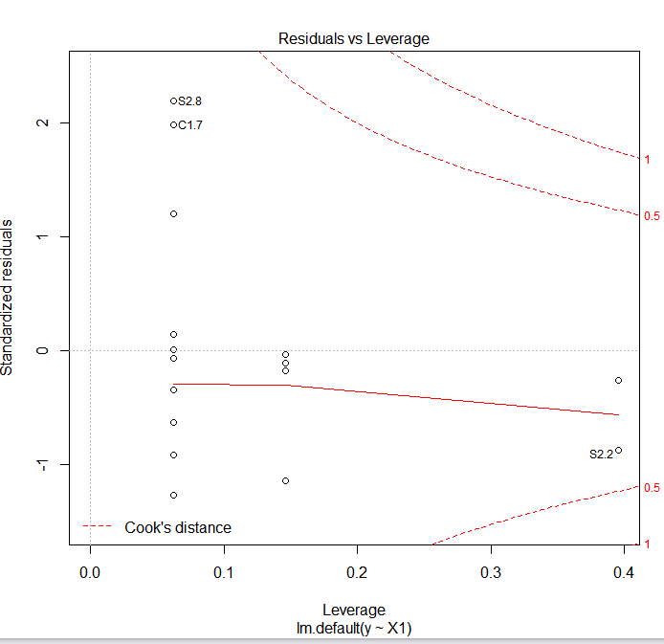

As shown above we don’t have any major outliers or influential points based on the commonly used heuristic of influential points with Cook’s distance greater than 1.

* **Non normality of residual error**

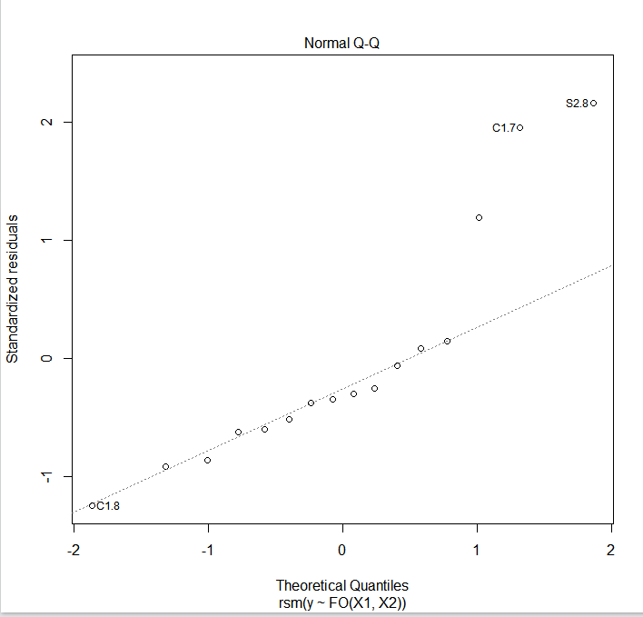

All our errors are within about 2 standard deviations. An attempt was made at removing the extreme points but it created a worse issue in the nested model.

* **Constancy of error variance**



This shouldn’t be surprising, since the error on all the center point runs is considerable. Further analysis using robust standard errors might be needed for a model consistent with the assumptions of Ordinary Least Squares.

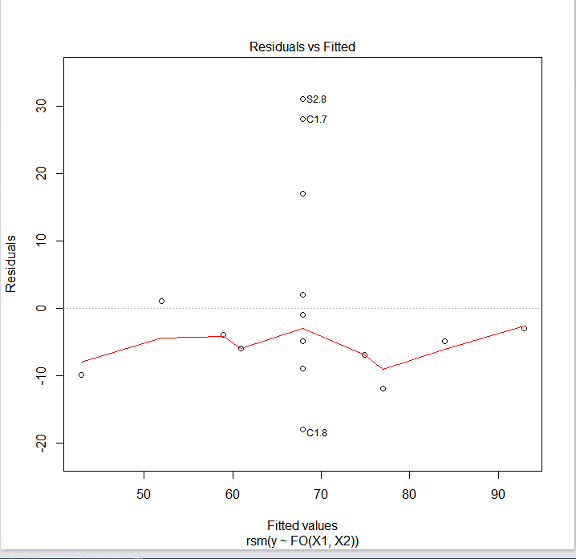

* **Correlation Test for Normality**

A correlation test of Normality gives a result of .9102. This implies that our residuals are independent of the predictor.

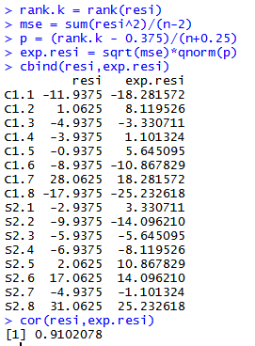

**Conclusions**

The contour plot shows us

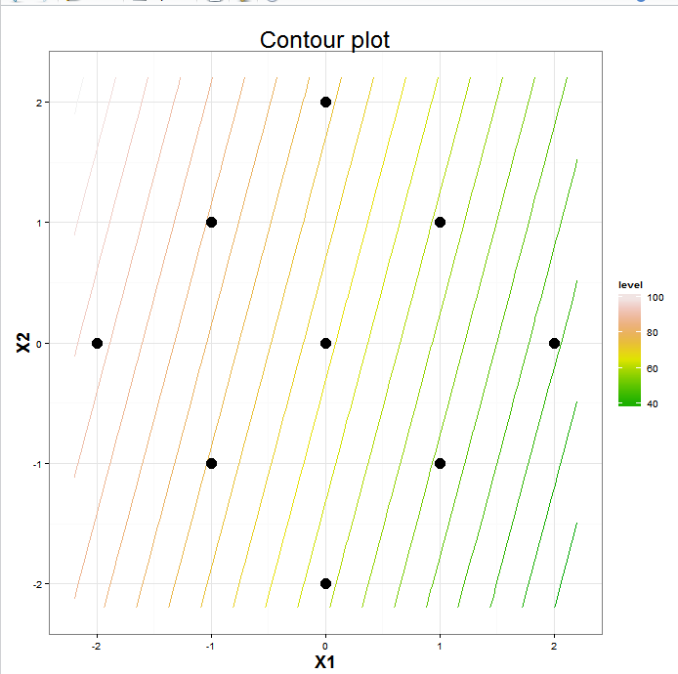

We can increase the time it takes to see bubbles by decreasing the amount of salt and increasing the amount of sugar. Conversely we can decreasing the amount of time it takes to see bubbles by increasing the amount of salt and decreasing the amount of sugar. A main effects plot can be seen as below

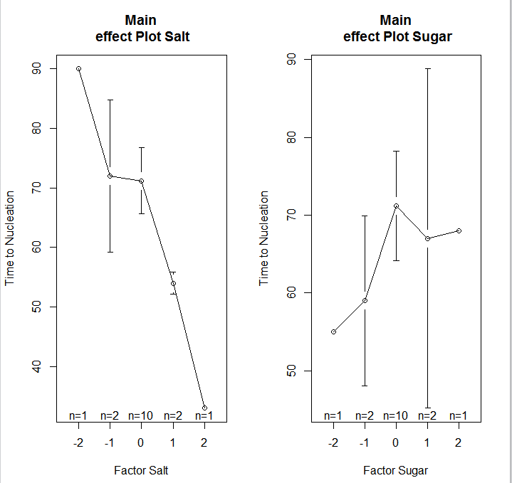  
Salt is a more important factor. The Sugar factor plot is shown for completion, however this factor is insignificant from our model.

**Appendix 1**  
The moments matrix is $M*16=\begin{matrix}16 & 0 & 0 \\ 0 & 12 & 0 \\ 0 & 0 & 12\end{matrix}$  
Since the first moments are equal and the odd moments are zero this is rotatable for first order. The advantage of this approach is that the elements of ˆ***β*** will be uncorrelated because the off-diagonal elements of Var(ˆ***β***) in will be zero. If the error vector is assumed to be normally distributed as *N*(**0**, *σ*2***I****n*) (as our diagnostics indicate), then these elements will be also stochastically independent.

1. P. W. Atkins, *Physical Chemistry*, 4th Ed., Oxford University Press, Oxford, 1994, [ISBN 0-19-269042-6](https://en.wikipedia.org/wiki/Special:BookSources/0192690426), p. 222-225
2. Sear, R. P. (2007).[*"Nucleation: theory and applications to protein solutions and colloidal suspensions"*](http://personal.ph.surrey.ac.uk/~phs1rs/review.pdf)(PDF).J. Physics Cond. Matt.**19**(3): 033101.[*Bibcode*](https://en.wikipedia.org/wiki/Bibcode):*[2007JPCM...19c3101S](http://adsabs.harvard.edu/abs/2007JPCM...19c3101S)*.[*doi*](https://en.wikipedia.org/wiki/Digital_object_identifier):[*10.1088/0953-8984/19/3/033101*](https://dx.doi.org/10.1088%2F0953-8984%2F19%2F3%2F033101).